**# Steps to Perform Ansible**

* Create EC2 Instance for the Ansible and the Nodes.

* Prerequisite is Linux only for the Ansible installation.

* Connect on EC2 Ansible.

Install Ansible

cmd: sudo yum install ansible -y

* Check Python version as it is installed automatically.

cmd: python3 --version



* Check Ansible version to verify it is installed correctly.

cmd: ansible --version

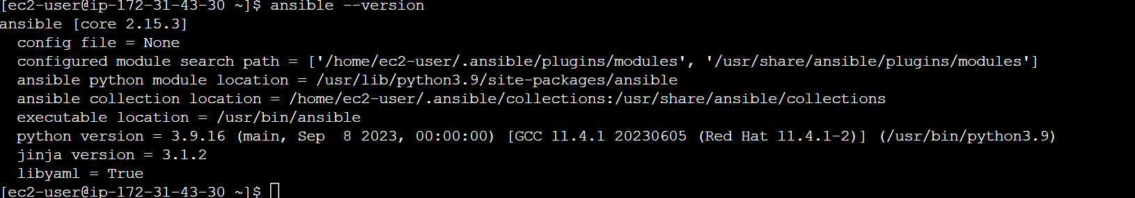

* Configure Ansible.

* Add the Target IPs into Inventories.

* Establish SSH Connection.

cmd: ssh-keygen

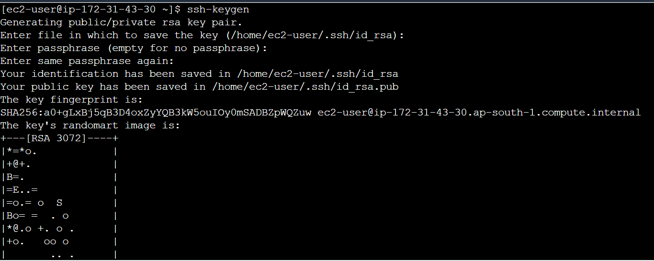

* Connect To Node EC2.

* Check the Authorized keys in the Node and add the public key from the ansible into the

node authorized key to establish the connection.

cmd: cd .ssh (cd: To Go to SSH directory)

cmd: ls (ls: Lists Instance Directory and file)

cmd: vi authorized_keys (vi: Used to create and edit files)

* Ansible Public key.

cmd: cd .ssh (cd: To Go to SSH directory)

cmd: ls (ls: Lists Instance Directory and file)

cmd: cat id_rsa.pub (vi: Concatenate or Display the Content of the File)

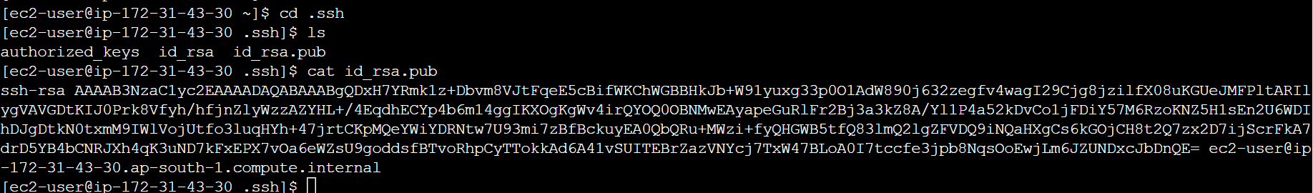

* Copy the Public key from Ansible and Paste it in Node.

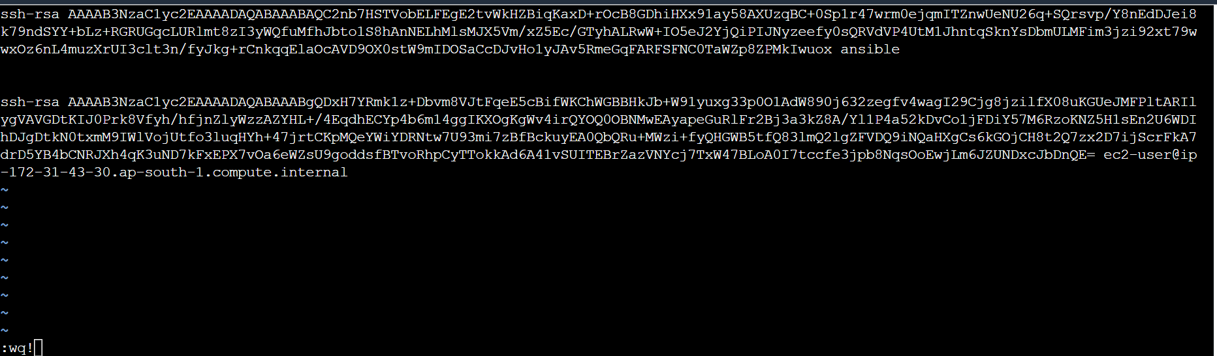

* Verify the Target Node connection we need to take the Node Private IP and try to establish the

connection on ansible.

cmd: ssh 172.*.*.* (Copy Your Node Private IP here)

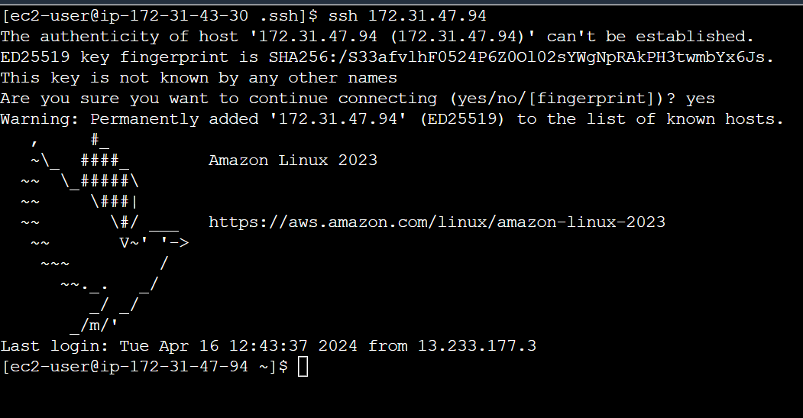

* Here connected with the node through ansible Now.

* Edit the inventory file and add the Node Private IP address.

cmd: vi inventory (vi: Used to create and edit files)

Copy pastes the Node Private IP address.

* Run Ansible adhoc commands

cmd: ansible -i inventory all -a "yum install git -y" -b

-i inventory : Take the Target Node into inventory.

all : select all target Nodes which is in the inventory file.

-a : ad hoc command

-b : became a root (permission)

* Check the Git Installed Version.

cmd: ansible -i inventory all -a "git --version" -b

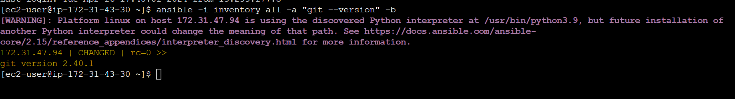

* Check the Git Installed Version in Node.

cmd: git –version

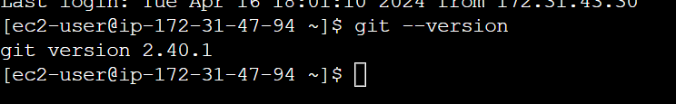

cmd: ansible -i inventory all -m yum -a "name=httpd state=latest" -b     #to install httpd

cmd: ansible -i inventory all -m service -a "name=httpd state=started" -b     #to start service

cmd: ansible -i inventory all -m service -a "name=httpd state=stopped" -b     #to stop service

cmd: ansible -i inventory all -m service -a "name=httpd state=absent" -b     #to uninstall service